**Project Title:**

**Real-Time Communication System Powered By AI For Specially Abled.**

**Mentor(s) Name:**

Shivani Kapoor, Indra Prakash.

**Faculty Name:**

Vinayagam.V.M

**Team Leader:** Sowmiya G(110319104041)

**Team Members:** Abirami v(110319104001)

Sneha BA(110319104040)

Akshaya S(110319104002)

Abstract:

In our society, we have people with disabilities. The technology is developing day by day but no significant developments are undertaken for the betterment of these people. Communications between deaf-mute and a normal person has always been a challenging task. It is very difficult for mute people to convey their message to normal people. Since normal people are not trained on hand sign language.

In emergency times conveying their message is very difficult. The human hand has remained a popular choice to convey information in situations where other forms like speech cannot be used. Voice Conversion System with Hand Gesture Recognition and translation will be very useful to have a proper conversation between a normal person and an impaired person in any language.

The project aims to develop a system that converts the sign language into a human hearing voice in the desired language to convey a message to normal people, as well as convert speech into understandable sign language for the deaf and dumb. We are making use of a convolution neural network to create a model that is trained on different hand gestures. An app is built which uses this model. This app enables deaf and dumb people to convey their information using signs which get converted to human-understandable language and speech is given as output.

**Technical Architecture:**

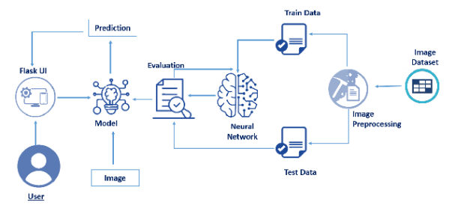

**Conclusion:**

The project is a straightforward example of how CNN may be applied to computer vision difficulties. The project is able to address a portion of the Sign Language translation problem because sign languages are spoken in context rather than as finger typing languages. This project can be improved in the future in a few ways. It could be constructed as a web or mobile application enabling users to access the project more easily. By experimenting with various background removal methods, we hope to obtain improved accuracy even in the situation of complicated backgrounds. For upgrading the preprocessing to better predict gestures in low-light situations is also being considered.

**References:**

[1] Yang, Jie and Y. Xu. “Hidden Markov Model for Gesture Recognition.” (1994), doi: 10.21236/ada282845.

[2] Pujan Ziaie, Thomas Muller, Mary Ellen Foster , and Alois Knoll “A Naive Bayes Munich,Dept. of Informatics VI, Boltzmannstr. 3, DE-85748 Garching, Germany.

[3] Hsien-I Lin, Ming-Hsiang Hsu, Wei-Kai Chen, “Human Hand gesture recognition using a convolution neural network”, 10.1109/CoASE.2014.6899454, August 2014

[4] Junho Yim, Jeongwoo Ju, Heechul Jung, Junmo Kim,“Image Classification Using Convolutional Neural Networks With Multi-stage Feature”, Robot Intelligence Technology and Applications 3, 2015, Volume 345, ISBN : 978-3-319-16840-1

[5] S. Shahriar et al., "Real-Time American Sign Language Recognition Using Skin Segmentation and Image Category Classification with Convolutional Neural Network and Deep Learning," TENCON 2018 - 2018 IEEE Region 10 Conference, 2018, pp. 1168-1171, doi: 10.1109/TENCON.2018.8650524.